Birla Institute of Technology & Science, Pilani
Work Integrated Learning Programmes Division
Second Semester 2023-2024

Comprehensive Examination
(EC-3 Regular)

Course No. : CSI ZG527
Course Title : Cloud Computing
Nature of Exam : Open Book
Weightage : 40%
No. of Pages = 2

No. of Questions = 5
Duration : 2 ½ Hours
Date of Exam : 19/05/2024 (AN)
Note to Students:
- Please follow all the Instructions to Candidates given on the cover page of the answer book.
- All parts of a question should be answered consecutively. Each answer should start from a fresh page.
- Assumptions made if any, should be stated clearly at the beginning of your answer.

- Answer the below questions (3+3+4=10)
  - State the purpose of having a private docker hub? If I’m connected to a private hub, can I connect to the public repository of docker? Give an example where such a scenario is applicable or not applicable.
  - JVM helps in the portability of java applications and Docker provides containerization. Are these two similar? Explain your answer.
  - Create a docker file to create a container using the latest version of ubuntu. Add commands to run a small script called myscript.py. The myscript.py has the following requirement in terms of libraries.
    - Requests
    - Pytube
Note: The command to install the libraries is “pip install <package name>”. You are to replace this with the packages respectively in your docker file creation.

- Modern cloud providers are increasingly advocating the practice of deploying applications which follows the Well architected framework. (WAF). The pillars of a WAF are.
  - Operational Excellence
  - Security
  - Reliability
  - Performance & Sustainability
  - Cost Effective
A startup company is looking to deploy their application on the cloud using the WAF, based on the above pillars, briefly the factors to consider for each of the above (2*5=10)

- Refer to the below architecture of Messy Inc. They have recently moved their application to the cloud. Answer the questions below (3+2+5 = 10)
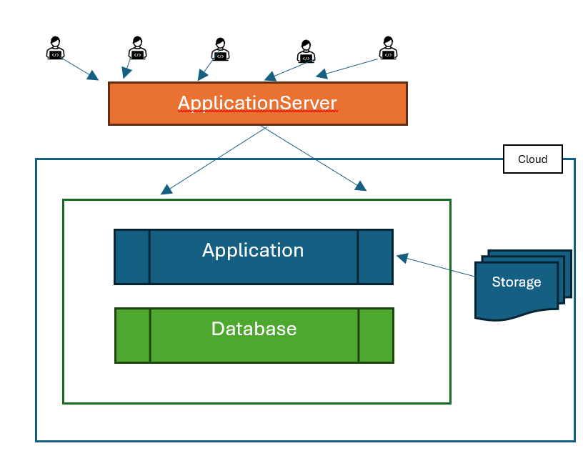
Figure 1:Messy Mart

  - Do you think the above architecture is sustainable? Give reasons.
  - Messy Mart is not able to automatically integrate with third party logistics (delivery partner, shipping partners etc). What would be the best option here?
  - The Users of the Messy Mart often complain about sluggish performance, give 5 reasons why the above application is sluggish and provide alternatives.

- From the below conditions for a cloud provider who has a 4-Node cluster, the current occupancy states are given below. Leases are described with start time, duration and whether its pre-emptable. (2+3=5)

Node 1 - L1 (1 pm, 1 hr, yes),
Node 2 - L2 (1.30 pm, 1 hr, No),
Node 3 - L3 (1 pm, 3 hr, No),
Node 4 - L4(now, 2 hr, No).

Now if two new Workload arrives in the form of lease l5 & L6 with description
L5 ( now, 1 hr, No) and
L6 ( 1.30 pm, 2hr , Yes)

Identify what type of lease L5 & L6 are. Briefly state why
Test & evaluate the leases for the BEL pre-emptive condition

- You have been asked to design an “Open File System” which is derived from HDFS architecture with following variances – chunk size of 50 MB, block size of 1 MB. A file of size 500GB needs to be stored on this file system: Marks: 1*5=5
  - How many chunks will be required to store the file?
  - How many blocks will be required to store the file?
  - How many chunk servers will be needed if each server hosts 1000 blocks?
  - How many chunk servers will be needed if each server hosts 100 GB of file?
  - How many chunk servers will be needed if the replication factor is 6 and the capacity of the chunk server is 200 GB?

